
SQL CLASSES – From Zero into Advanced
Started date: November, 23rd of 2025
Channel: Data with Baraa

Summary

Lecture Number | Completion Date | Content talked
Lecture 01 | November 23rd | How I would learn SQL (Study Plan)
Lecture 02 | xxx | What is SQL (Visually Explained)
Lecture 03 | November 4th | How to setup and install SQL server
Lecture 04 | xxx | SQL SELECT Queries – All Essential Clauses
Lecture 05 | November 28th | DDL -Data Definition Language – CREATE, ALTER, DROP
Lecture 06 | November 28th | DML – Data Manipulation Data – INSERT, UPDATE, DELETE
Lecture 07 | December 1st | WHERE Conditions – AND, OR, NOT, LIKE, BETWEEN, IN
Lecture 08 | December 2nd | JOINS basics – INNER, LEFT, RIGHT, FULL
Lecture 09 | December 3rd | Advanced SQL JOINS – ANTI, CROSS
Lecture 10 | December 3rd | JOINING MULTIPLE TABLES IN SQL
Lecture 11 | December 4th | SET OPERATORS – UNION, UNION ALL, EXCEPT, INTERSECT
Lecture 12 | December 8th | FUNCTIONS IN 5 Minutes
Lecture 13 | December 8th | String Functions – A Detailed Guide
Lecture 14 | December 8th | Number Functions
Lecture 15 | December 9th | Date & Time - DATEPART, DATENAME, DATETRUNC, EOMONTH
Lecture 16 | December 15th | Date & Time – FORMAT, CONVERT, CAST
Lecture 17 | December 15th | Date & Time - DATEADD, DATEDIFF, DATESUB, ISDATE
Lecture 18 | December 22nd | COALESCE, ISNULL, NULLIF IS (NOT) NULL
Lecture 19 | December 22nd | NULL vs Empty String vs Blank Space
Lecture 20 | February 25th | CASE WHEN Statement
Lecture 21 | March 4th | Aggregate Functions – COUNT, SUM, AVG, MAX, MIN
Lecture 22 | March 4th | Window Functions Basics – PARTITION BY, ORDER BY
Lecture 23 | March 26th | Aggregate Window Functions – COUNT, AVG, SUM, MAX, MIN
Lecture 24 | April 3rd | Ranking Window Functions – ROW_NUMBER, RANK, DENSE_RANK
Lecture 25 | April 3rd | Value Window Functions – LEAD, LAG, FIRST_VALUE, LAST_VALUE
Lecture 26 | April 4th | Five SQL Techniques You Need in Every Project
Lecture 27 | April 13th | Subqueries – Complete Guide
Lecture 28 |  | CTE (Common Table Expression)
Lecture 29 |  | Views – Six Top Use Cases
Lecture 30 |  | CTAS – How to Create SQL Tables from a query
Lecture 31 |  | Temp Tables
Lecture 32
Lecture 33 |  | Indexes – Clustered vs Nonclustered
Lecture 34
Lecture 35 |  | Unique and Filtered Indexes
Lecture 36 |  | How to Choose the Right Index
Lecture 37 |  | Index Maintenance – Five things to Do after Creating Indexes
Lecture 38 |  | Execution Plans – SQL Hints
Lecture 39 |  | My Indexing Strategy for Every SQL Project – Indexing Best Practices
Lecture 40 |  | Table Partitioning – Optimize Big table Performance
Lecture 41 |  | Thirty SQL tips and Tricks From 18 Years of Experience
Lecture 42 |  | Stored Procedure – Comprehensive Guide
Lecture 01:

Content: How I would learn SQL (Study Plan) | Date: November, 23rd

The order to learn everything about SQL:
FROM #1 UNTIL #4 -> BEGINNER-LEVEL
FROM #5 UNTIL #8 -> INTERMEDIATE-LEVEL
FROM #9 UNTIL #12 -> ADVANCED-LEVEL

#1 Introduction | Theory  What is SQL,  Why learn SQL,  What is Database & Types,  SQL Commands,  SQL Components,  SQL Coding Style
#2 Query Data (SELECT) | How to get the data  SELECT  FROM  WHERE  ORDER BY  GROUP BY  HAVING  DISTINCT  TOP
#3 Data Definition (DDL) | How to define a database  CREATE  ALTER  DROP
#4 Data Manipulation (DML) | How to manipulate the data  INSERT  UPDATE  DELETE
#5 Filtering Data | How to filter the data  Comparison operators  Logical Operators  BETWEEN  IN  LIKE
#6 Combining Data | How to combine the data  Joining Data  Basic Joins:  INNER JOIN  LEFT JOIN  RIGHT JOIN  FULL JOIN  Advanced Joins:  LEFT ANTI JOIN  RIGHT ANTI JOIN  FULL ANTI JOIN  CROSS JOIN  How to Choose the Right Join  How to Join Multiple Tables  SET Operators:  UNION  UNION ALL  EXCEPT  INTERSECT
#7 Row-Level Functions | String Functions  Number Functions  Date & Time Functions  Null Functions  Case Statement  For Data Engineers*
#8 Aggregation & Analytical Functions | How to do data transformation  Aggregate Functions  Window Basics  Window Aggregate Functions  Window Ranking Functions  Window Value Functions  For Data Analysts*
#9 Advanced SQL Techniques | Subqueries  Common Table Expression (CTE)  Views (if learn, will become really profession)  CTAS Table & Temp Tables  Stored Procedure (How to write a program)  Triggers
#10 Performance Optimization | How to optimize the performance  Indexes  Partitions  Performance Tips
#11 AI & SQL | How to write correct prompts to get assistence from AI on a SQL Project
#12 SQL Projects | Use all you learned on three types of projects  Data Warehousing Project (Data Engineering Focus)  Exploratory Data Analysis (EDA) Project  Advanced Data Analytics Project

Lecture 02

Content: What is SQL (Visually Explained) | Date: xxx

Database
A container that stores data
Why use Database
To ‘ask questions’ about the Data, and get the answer about the Data rapidly;
Databases can handle really huge amount of Data;
Databases are more secure than a simple CSV or Text file.

SQL
Is the Language we use to ‘talk’ to the Database, SQL Mean Structured Query Language

Database Management System (DBMs)
It will manage all requests sent to the Database, the security, and other things.

Server
A Database usually stay in a server (a big powerful computer that stay powered on 24/7, rarely goes offline)

Types of Databases
SQL
Relation like spreadsheets, we have tables, columns and lines, and relationships between the tables
- EXAMPLES: Microsoft SQL SERVER, MYSQL, POSTGRESQL

NOSQL
Key-Value Has pairs of keys and values, where the key point to the value
- EXAMPLES: REDIS, AMAZON DYNAMDB
Column-based group the data into columns
- EXAMPLES: APACHE CASSANDRA, AMAZON REDSHIFT
Graph focus on relationships between objects
- EXAMPLES: NEOHJ
Document The data is stored as entire documents. The structure of the data is not important, what is more important is to fit everything in one page
- EXAMPLES: MONGODB

Database Structure
- Servers host Databases;
- Databases hold Schemas
- Schemas hold Tables and Relationships
- Tables store records
Server A powerful computer that hosts the Database 24/7, all the time online.
Database A container that stores data.
Schemas The structure of the Database (Tables, Relationships, Attributes).
Tables Organizes the data into column and lines.

Table Example
table_user
user_id | user_name | User_password

Every line is a Record, individual from all others,
Every column is a property of the item

Primary key
A unique identifier for each Record in a table

Data Types
What kind of Data we store into a table

Examples of Data Types
Numeric
Int 1, 2, 30

Text(string)
Char ‘A’ ‘1’
Varchar ‘maria’ ‘johnny’

Date and Time
Date ‘2025-12-25’
Time ’09:22:15’

Types of SQL COMMANDS

Supposing you have an empty Database, and you want to create a table - you use the DDL COMMANDS

Then, you need to create a table - you need DML COMMANDS

Once the Data is into the Table, we can start asking questions with DQL COMMANDS

DDL (Data Definition Language)
CREATE, ALTER, DROP

DML (Data Manipulation Language)
INSERT, UPDATE, DELETE

DQL (Data Query Language)
SELECT

Why learn SQL?
Most part of the companies stores their Data into databases and you need to talk for the Data, ask questions for the Data

High Demand
Software Developer, Data Analyst, Data Engineer, Data Scientist, you need to have SQL Skills

Industry Standards
Most modern Data applications use SQL Commands

Lecture 03

Content: How to setup and install SQL server | Date: November, 24th

Nothing important, we just have configured the databases that will be used the whole course

Lecture 04

Content: SQL SELECT Queries – All Essential Clauses | Date: xxx

How to query the data using SQL
Commands
SELECT, DISTINCT, TOP(LIMIT), FROM, WHERE, GROUP BY, ORDER BY, HAVING
What is a SQL Query
SQL Query can be understood as a command line that focus in answer question about your data stored inside a database.

SQL Clauses
SELECT *
Retrieves All Columns (Everything)
FROM
Tells SQL Where to find your data
SELECT * FROM table_name
Retrieves the whole table, and then select everything

SELECT few columns
Pick only the columns you need instead of all
SELECT
Col 1,
Col 2,
FROM table_name

WHERE
Filter your data based on a condition
SELECT *
FROM
WHERE condition

ORDER BY
Sort your data
It can be ASC or DESC
Ascending or Descending
SELECT *
FROM
ORDER BY column_used_to_order mechanism(ASC/DESC)
Default mechanism is ASC, but it is important to write for code clarity
SORT DATA USING MULTIPLE COLUMNS (NESTED SORTING)
ORDER BY col1 ASC, col2, DESC
The order of columns is very important.

GROUP BY
Combine rows with the same value
Aggregates a column by another column
Total score by country
SELECT
Country, -> Category
SUM(score) -> Aggregation
From table
GROUP BY country

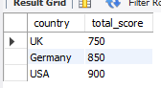
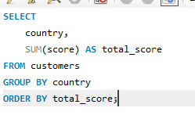
You can combine all of them
SUM() AS name -> Alias (shorthand name assigned to a column or table in a query

GROUP BY RULE
All columns in the SELECT must be either aggregated or included in the GROUP BY

HAVING
Filter data after aggregation, can be used only with GROUP BY
GROUP BY
HAVING condition

WHERE = Before aggregation
HAVING = After aggregation

Find the average score for each country, considering only customers with a score not equal to 0 and return only those countries with an average score greater than 430
Answer:

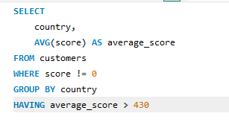
DISTINCT
Removes duplicates (repeated values)
Each value appears only once
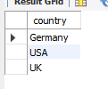
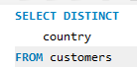

TOP/LIMIT
Restrict the number of rows returned in the results
SELECT *
FROM Table
LIMIT 3

Coding Order

SELECT DISTINCT TOP 2
COL1,
SUM(COL2)
FROM TABLE
WHERE COL = 10
GROUP BY COL1
HAVING SUM(COL2)>30
ORDER BY COL1 ASC

- Filter Columns
- Filter Duplicates
- Filter Result Rows
- Filter Rows Before Aggregation
- Filter rows after aggregation
Execute Order
- FROM
- WHERE
- GROUP BY
- HAVING
- SELECT DISTINCT
- ORDER BY
- TOP
My comments
In SQL, you cannot use the alias total_students inside HAVING. That alias only works in the SELECT and ORDER BY sections.

Lecture 05

Content: DDL -Data Definition Language – CREATE, ALTER, DROP | Date: November 28th

DDL commands do not retrieve data, just create or alter the structure of the data

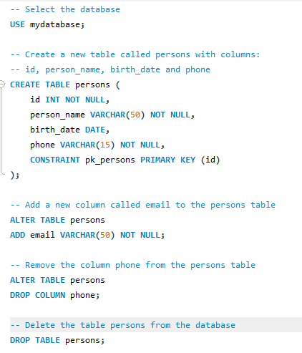
CREATE
Define the structure of your data
CREATE DATABASE
CREATE TABLE

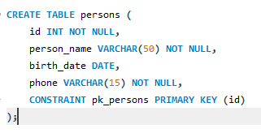
You can use
CONSTRAINT alias PRIMARY KEY (column)
to define the PRIMARY KEY of a table

ALTER
if you want to edit a table, you can use table to
remove or add a column
change the type of a column

About adding columns, the new column are appended at the end of table by default
If you want to change the order of the columns, you’ll have to DROP table, and then create again

DROP
Used to delete a database or a table.

DROP TABLE table_name
DROP DATABASE database_name

Lecture 06

Content: DML – Data Manipulation Data – INSERT, UPDATE, DELETE | Date: November 28th

INSERT
There are two methods to insert data into tables in SQL
Manually Entry (Values)
You type a query and specify the data manually using SQL scripts

Insert Using SELECT
You insert the results of a SELECT query from one table into another table
It can be made using INSERT INTO + SELECT QUERY
First you retrieve the data with SELECT Query, then, you insert the results with INSERT INTO (you write just one query INSERT + SELECT)

MANUALLY INSERT SYNTAX
INSERT INTO table_name (column1, column2, column3)
VALUES (value1, value2, value3);

First you must specify the columns you want to insert information into the table and then, you must specify the data you will insert into the table.
IMPORTANT
Columns and values must be in the same order.
If no columns are specified, SQL expects values for all columns.
The database doesn’t care about the order of the values as long as they match the correct data types, However, you must not enter values into the wrong column. (Matching data types, column count and constraints)
You can skip the columns if you insert values for every column
Columns not included in INSERT become NULL (unless a default or constraint exists)

TIPS
Always list columns explicitly for clarity and maintainability

Insert Using SELECT Syntax
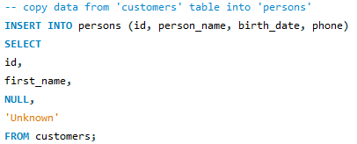
First, you retrieve the data from the source table, and then, the results are inserted into the destination table
You must match the data types to avoid errors

UPDATE
Change the data of already existing row

UPDATE SYNTAX
UPDATE table_name
SET
column1 = value1,
column2 = value2
WHERE <condition>

Note
ALWAYS use WHERE to avoid updating all rows unintentionally, without a WHERE, all rows will be updated!

Best Practice
Check with SELECT before running UPDATE to avoid updating the wrong data

DELETE
Delete a row from the table
DELETE Syntax
DELETE FROM table_name
WHERE <condition>

Note
ALWAYS use WHERE to avoid DELETING all rows unintentionally, without a WHERE, all rows will be deleted!

TRUNCATE
Clears the whole table at once without checking or logging (it has a better performance than DELETE FROM tbl_name)
Behind the scenes, DELETE FROM is much slow due logs and protocols.

Here, I’ve completed the beginner-level, all the basics commands and syntaxes
Lecture 07

Content: WHERE Conditions – AND, OR, NOT, LIKE, BETWEEN, IN (Start of Intermediate Part) | Date: December 1st

WHERE Operators
Comparison operators: =, <> =!, >, >=, <, <=
Logical operators: AND, OR, NOT
Range operator: BETWEEN
Membership operator: IN, NOT IN
Search operator: LIKE

Comparison operators
Compare two things, like:
Column = Column2
Column1 = value
Function = value
Expression = value
Subquery = value

= (equal)
Checks if two values are equal

!= <> (not equal)
Checks if two values are not equal

> (greater)
Checks if a value is greater than another value

>= (greater or equal)
Checks if a value is greater than or equal to another value

< (less)
Checks if a value is less than another value

< (less or equal)
Checks if a value is less than or equal to another value

Logical operators

AND: All conditions must be true
OR: At least one condition must be true
NOT: (reverse) Exclude matching values

Range operator
Checks if a value is within a range
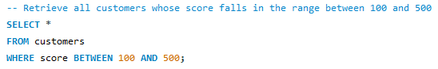

Membership operators
IN: Checks if a value exists in a list
NOT IN: Checks if a value NOT exists in a list
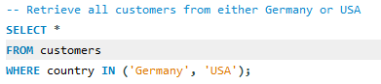
Use In instead of OR for multiple values in the same column to simplify SQL

Search operator
LIKE: search for a pattern in text

You can use two placeholders for it: ‘%’ and ‘_’ (percent sign and underscore, respectively)
‘%’ -> used to symbolize the characters in that position don’t matter. (It can be zero, one, many chars).
‘_’ -> used to symbolize exactly one char position. (Exact one char).

Examples
M%
First position must be an M, and the remaining characters can be zero, one or more (anything)

Maria -> matches the pattern
Ma -> matches the pattern
M -> matches the pattern
Emma -> Doesn’t match the pattern

%in
Anything at the start, but the last two characters must be in.

Martin -> matches the pattern
Vin -> Matches the pattern
In -> matches the pattern
Jasmine -> doesn’t match the pattern

%r%
Can have anything at the start and end, but must contain an r somewhere.
Maria -> matches the pattern
Peter -> matches the pattern
Rayn -> matches the pattern
R -> matches the pattern
Alice -> doesn’t match the pattern

__b%
The first two letters must exist, the third character must be ‘b’, and the remaining characters can be anything

Albert -> matches the pattern
Rob -> matches the pattern
Abel -> doesn’t match the pattern
An -> Doesn’t match the pattern

OFFSET CLAUSE
Usually used with LIMIT. It can be used to skip a certain number of rows on the data retrieved
Example:
LIMIT 1 OFFSET 1; -> Limits the search in one row, and jump one row from the start (if the table is alphabetically ordered, then returns the second alphabetically)

Lecture 08

Content: JOINS basics – INNER, LEFT, RIGHT, FULL | Date: December 2nd

What are SQL JOINS
You use them to combine two or more tables to combine the result by matching a key value
When to use JOINS
- Recombine data: The data might be in different tables, and you want to combine all data in just one table
INNER, LEFT, FULL
- Data Enrichment “Get extra data”: You want to get extra information from another table
LEFT
- Check for Existence ‘filtering’: Check if data from one table is in another table
INNER, LEFT + WHERE, FULL, LEFT ANTI JOIN, FULL ANTI JOIN

JOIN TYPES
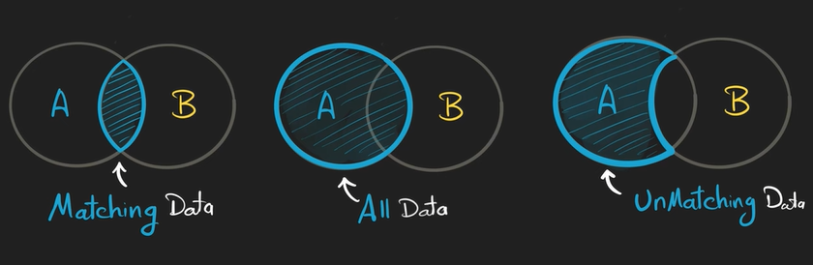
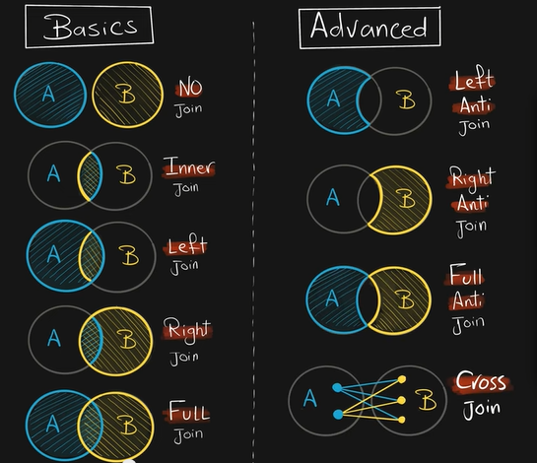
Basics
Two Results (NO JOIN)

Returns data from tables without combining them
You want to see all rows from A and B
SELECT * FROM A; SELECT * FROM B;

INNER JOIN

Return the matching rows from both tables
SELECT * FROM A INNER JOIN B ON A.key = B.key
ON <condition>: you must specify a common column in both of the tables.
On INNER AND FULL JOIN, tables order doesn’t matter
DEFAULT: INNER
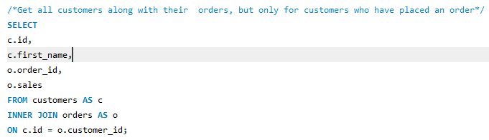
Best Practices
For long table names, you can add an alias for the tables, like:
FROM customers AS c
Then every time you want to reference that table, you use:
c.column name
For clarity, you may specify which value comes from which table

LEFT JOIN


Returns all rows from LEFT and only matching from RIGHT
A is the primary source of data and B is the secondary (additional data)

SELECT * FROM A LEFT JOIN B ON A.key = B.key
On LEFT JOIN, the order matter, you must specify the correct order of the tables
SQL places all data of LEFT table, and just after it, checks the matching in the RIGHT table

“You get all stuff from LEFT table, and just the matching from the RIGHT table”

RIGHT JOIN


Returns all rows from RIGHT and only matching from LEFT
B is the primary source of data and A is the secondary (additional data)
SELECT * FROM A RIGHT JOIN B ON A.key = B.key
On RIGHT JOIN, the order matter, you must specify the correct order of the tables

FULL JOIN


Returns all rows from both tables

SELECT * FROM A FULL JOIN B ON A.key = B.key
On INNER AND FULL JOIN, tables order doesn’t matter

Lecture 09

Content: Advanced SQL JOINS – ANTI, CROSS | Date: December 3rd

LEFT ANTI JOIN

Returns row from LEFT table that has NO MATCH in RIGHT table
Only data source is primary (A)
SELECT * FROM A LEFT JOIN B ON A.key = B.key WHERE B.key IS NULL
With the WHERE clause, SQL will retrieve only non-matching rows (B.key IS NULL)
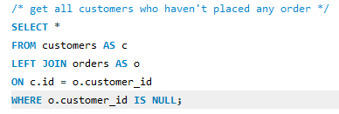
RIGHT ANTI JOIN

Returns row from RIGHT table that has NO MATCH in LEFT table
Only data source is primary (B)
SELECT * FROM A RIGHT JOIN B ON A.key = B.key WHERE A.key IS NULL
With the WHERE clause, SQL will retrieve only non-matching rows (B.key IS NULL)

FULL ANTI JOIN

Returns only rows that don’t match in either table
ONLY UNMATCHING DATA
SELECT * FROM A FULL JOIN B ON A.key = B.key WHERE B.key IS NULL OR A.key IS NULL
MYSQL WARN
MySQL does not have FULL JOIN and FULL ANTI JOIN, then it’s necessary to combine LEFT JOIN and RIGHT JOIN using UNION, see the example for each one:
FULL JOIN
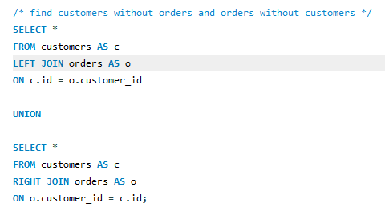
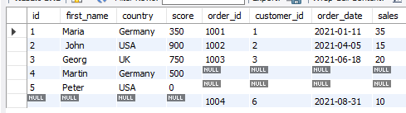
FULL JOIN retrieves everything, even orders that don’t have a customer and customers that have ordered nothing as well.

FULL ANTI JOIN
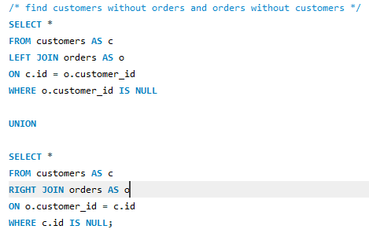
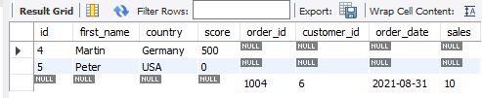
LEFT JOIN retrieves customers on the LEFT and RIGHT JOIN retrieves orders on the RIGHT. It just happens for orders that don’t have a customer and for customers that ordered nothing.
CROSS JOIN

Combines every row from LEFT with every row from RIGHT
All possible combinations – Cartesian Join
SELECT * FROM A CROSS JOIN B

Lecture 10

Content: JOINING MULTIPLE TABLES IN SQL | Date: December 3rd

Multi-Table Join
Start with the main table (A) of the analysis
Get extra data from table (B) using left
Get extra data from table (C) using left
Use WHERE clause to control what to keep
SELECT *
FROM A
LEFT JOIN B
LEFT JOIN C
LEFT JOIN D
WHERE

Lecture 11

Content: SET OPERATORS – UNION, UNION ALL, EXCEPT, INTERSECT | Date: December 4th

What are SET OPERATORS
Combine the results of multiple queries into a single result set.

Difference between JOINs and SETs
JOINs: Used to combine column
Must be connected by a Key column
TYPES OF JOINS: INNER JOIN, LEFT JOIN, RIGHT JOIN AND FULL JOIN

A | B | C | D
Table | 01 | Table | 02

SETs: Combine the rows
Must have the same number of columns
TYPES OF SETs: UNION, UNION ALL, EXCEPT, INTERSECT

A | B
Table | 01
Table | 02

Syntax and Rules

SELECT *
FROM Customers

UNION

SELECT *
FROM Employees

You have two different queries, and you put the SET operator between them

#1 Rule | SQL Clauses
SET Operators can be used almost in all clauses
WHERE | JOIN | GROUP BY | HAVING

But there is one exception
ORDER BY is allowed only once at the end of query
Do not use ORDER BY in each query, only at the end
Example:
SELECT *
FROM Customers

UNION

SELECT *
FROM Employees

ORDER BY FirstName

#2 Rule | Number of Column
The number of columns in each query must be the same
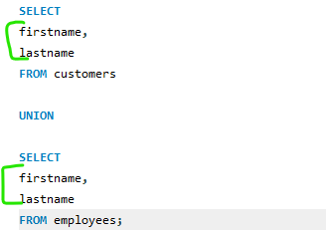

#3 Rule | Data Types
Data types of columns in each query must be compatible
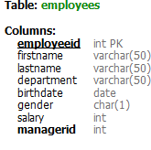
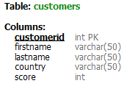

Using the previous query as example, as you can see, each specified column has the same data type

#4 Rule | Order of Columns
The order of the columns in each query must be the same

As you can see, both queries start with firstname and after, lastname.

#5 Rule | Column Aliases
The column names in the result set are determined by the column names specified in the first query.
The first query is responsible for naming the column of the result.

#6 Rule | Correct Column
Even if all rules are met and SQL show no errors, the result may be incorrect.
Incorrect column selection leads to inaccurate results.

In short, all Rules:
- ORDER BY can be used only once
- Same number of columns
- Matching data types
- Same order of columns
- First query controls aliases
- Mapping correct columns

UNION

Return all DISTINCT and UNIQUE rows from both queries
Removes duplicate rows from the result
UNION ALL

Returns all rows from both queries, including duplicates
UNION ALL is generally faster than UNION
If you’re confident there are no duplicates, use UNION ALL
Use UNION ALL to find duplicates and quality issues

EXCEPT (MINUS)

Returns all distinct rows from the first query that are not found in the second query
The order of the queries affects the final result
It is the only one where the order of queries affects the final result

INTERSECT

Return only the rows that are common in both queries
Remove duplicates as well

UNION Uses – Combine Information
Combine similar information before analyzing the data
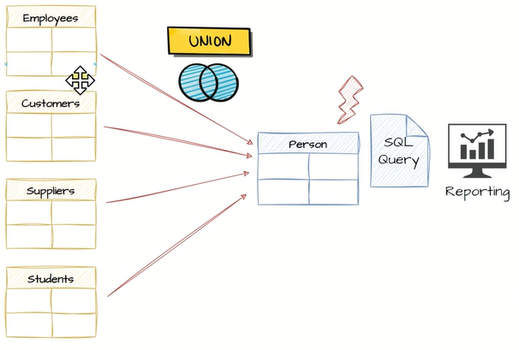
Database developers divide the data into multiple tables to optimize performance and archive old data
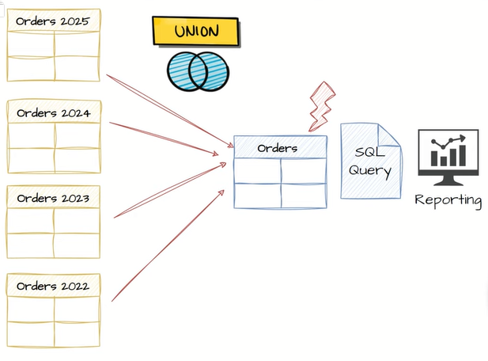

You can add a static column in your data analysis to specify the source of the data (where the data comes from)
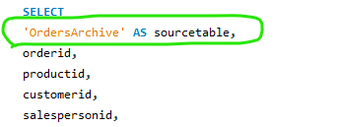
Result
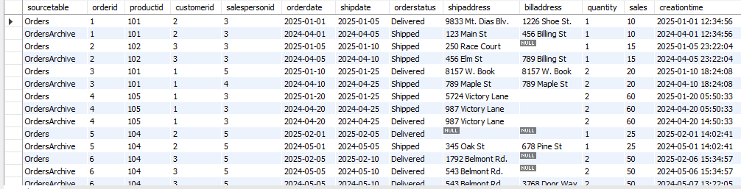

EXCEPT Uses – Delta Detection
Identifying the difference or changes (delta) between two batches of data
For example, data engineers build data pipelines in order to load daily new data from the source systems to a data warehouse of a data lake. Now in those data pipelines we have to build a logic in order to identify what are the new data that is generated from the source system in order to insert it in the data warehouse. One way to do it is to use the set operator accept in order to compare the current data with the previous load.
EXCEPT Uses – Data Completeness Check
Except operator can be used to compare tables to detect discrepancies between databases
For example, you want to pass all records from Database A to Database B, and after doing the process, you want to check if all data have been moved successfully, then you can use the SET operator EXCEPT between the two tables from the two Databases, in order to find any record that is still in Database A which is not migrated to the Database B, and the best result is that we will not get anything. That means all the rows from database A exist in the database B.
Summary
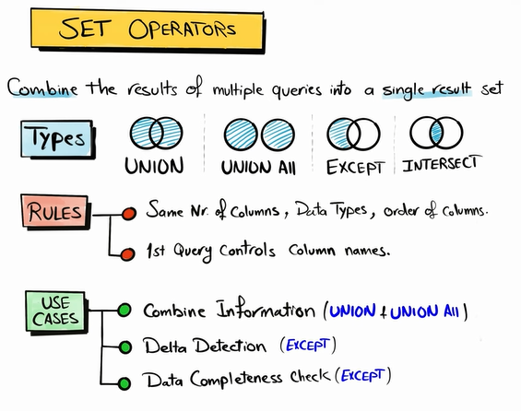
Lecture 12

Content: FUNCTIONS IN 5 Minutes | Date: December 8th

You will use functions every time you want to do these things with data:
- Manipulate
- Analyze
- Transform
- Clean
Functions are a built-in SQL CODE
- Accepts an input value
- Processes it
- Returns an output value
Two Functions Categories
- Single-row functions: receives one value and return only one value
- Multi-row functions: receives many values and returns one or more values
Nested Functions
Function used inside another function
Types of SQL Functions
Single-row Functions
- String Functions
- Numeric Functions
- Date and Time Functions
- NULL Functions
Multi-row Functions
- Aggregate Functions (basics)
- Window Functions (advanced)
Lecture 13

Content: String Functions – A Detailed Guide | Date: December 8th

String Functions Groups
Manipulation
- CONCAT
- UPPER
- LOWER
- TRIM
- REPLACE
Calculation
- LEN
String Extraction
- LEFT
- RIGHT
- SUBSTRING

CONCAT()
Combines multiple strings into one value
You have one value ‘Michael’
And you have another value ‘Scott’
CONCAT() -> ‘Michael’ + ‘Scott’ = ‘Michael Scott’
Syntax and Result
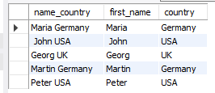
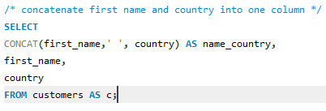

LOWER() and UPPER()
- UPPER: Converts all characters to uppercase
- LOWER: Convers all characters to lowercase
Syntax and Result
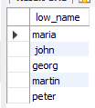
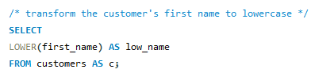

TRIM()
Removes leading and trailing spaces from a string
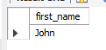
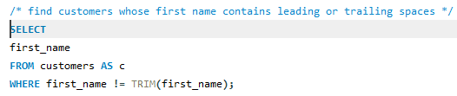

REPLACE()
Replaces specific character with a new character
You have to specify the old value and the new value
Can be used to remove characters as well
Examples of use
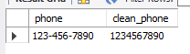
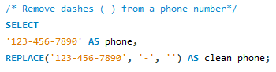
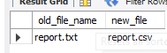
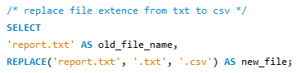

LEN() / LENGTH
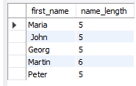
Counts how many characters there are
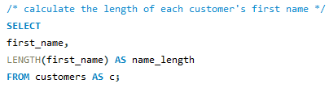
LEFT() and RIGHT()
LEFT(var_name, length)
- LEFT() – Extracts specific number of characters from the start
- RIGHT() - Extracts specific number of characters from the end
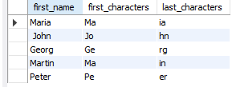
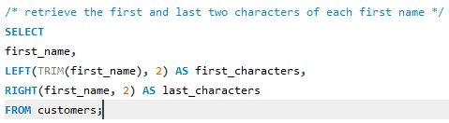

SUBSTRING
SUBSTRING(var_name, start, length)
Extracts a part of string at a specified position

Lecture 14

Content: Number Functions | Date: December 8th

ROUND()
Approximates a number to the number of decimal points chosen
example:
3.516 and ROUND 2 = 3.52
3.516 and ROUND 1 = 3.5
3.516 and ROUND 0 = 4

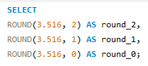
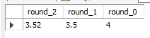

ABS()
Return the absolute (positive) value of a number, removing any negative sign

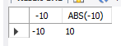
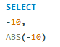

Lecture 15

Content: Date & Time - DATEPART, DATENAME, DATETRUNC, EOMONTH | Date: December 9th

What is DATE & TIME
Date is a representation of Year, Month and Day (YYYY-MM-DD)
Time is a specific hour of a day (HH-MM-SS)
Date + Time = Timestamp / Datetime
Order: YYYY-MM-DD + HH:MM:SS

Values
There are three different sources in order to query the date
- Date column from a table
- Hardcoded constant string value
- GETDATE() Function
GETDATE() (or CURRENT_TIMESTAMP() in mysql)
Returns the current date and time at the moment when the query is executed

Functions Overview
With functions you can
- Extract a part of the date, like only year, month, day
- Change the format
- Make calculation with dates, like add, diff
- Make validations

Date & Time functions grouped
Part Extraction
- DAY
- MONTH
- YEAR
- DATEPART | EXTRACT
- DATENAME |
- DATETRUNC
- EOMONTH
Format and Casting
- FORMAT
- CONVERT
- CAST
Calculations
- DATEADD
- DATEDIFF
Validation
- ISDATE

DAY | MONTH | YEAR
Return respectively the day, month and the year from a date
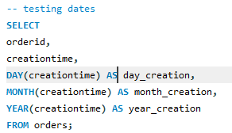
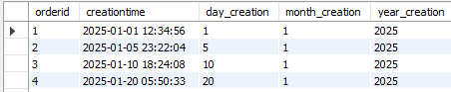

DATEPART | EXTRACT in MySQL
Returns a specific part of a date as a number
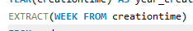
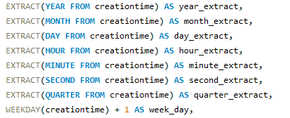

DATENAME | (MONTHNAME | DAYNAME in MySQL)
Returns the name of a specific part of a date (specially month and day)
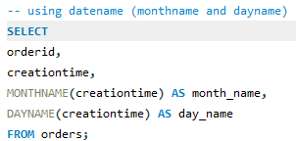

DATETRUNC
Truncates the date to the specific part
DATETRUNC(hour) -> remove all information after hour (removes minutes and seconds)
DATETRUNC(day) -> keep year, month, day and remove all information about the time

EOMONTH | LAST_DAY in MySQL
Returns the last day of a month
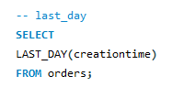

Lecture 16

Content: Date & Time – FORMAT, CONVERT, CAST | Date: December 15th

What is date format
YYYY-MM-dd HH:mm:ss
These letters are format specifier.
International Standard (iso 8601)
YYYY-MM-dd
USA Standard
MM-dd-YYYY
European Standard
dd-MM-YYYY

Formatting and Casting
Formatting: changing the format of a value from one to another (FORMAT)
- MM/dd/yy -> 08/20/25
- MMM YYYY -> Aug 2025
CONVERT
- 6 -> 20 Aug 25
- 112 -> 20250820
FORMAT for numbers
1234567.89
- N-> 1,234,567.89
- C -> $1,234,567.89
- P -> 123,456,789.00%
CASTING
Changing the data type from one to another
- String ‘123’ -> 123 number
- Date 2025-08-20 -> ‘2025-08-20’ String
- String ‘2025-08-20’ -> 2025-08-20 Date
Functions: CAST() OR CONVERT()

FORMAT()
Formats a date or time value
- FORMAT(value, format [,culture])
- FORMAT(OrderDate, ‘dd/MM/yyyy’)
- FORMAT(Orderdate, ‘dd/MM/yyyy’, ‘ja-JP’)
- FORMAT(1234.56, ‘D’, ‘fr-FR’)
For MySQL, use data_format to treat dates
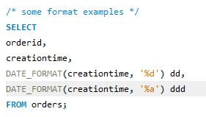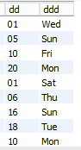
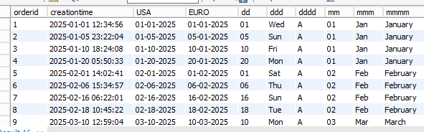
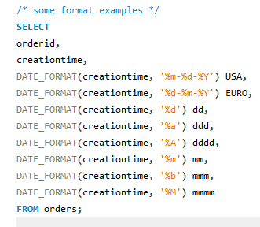

MySQL DATE_FORMAT – All Formats for Date/Time
Format | Description
%a | Abbreviated weekday (Sun to Sat)
%b | Abbreviated month name (Jan to Dec)
%c | Numeric month name (0-12)
%D | Day of the month as a numeric value, followed by suffix (1st, 2nd, 3rd,…)
%d | Day of the month as a numeric value (01-31)
%e | Day of the month as a numeric value (0-31)
%f | Microseconds (000000 to 999999)
%H | Hour (00 to 23)
%h | Hour (00 to 12)
%I | Hour (00 to 12)
%i | Minutes (00 to 59)
%j | Day of the year (001 to 366)
%k | Hour (00 to 23)
%l | Hour (00 to 12)
%M | Month name in full (January to December)
%m | Month name as a numeric value (00-12)
%p | AM or PM
%r | Time in 12 hour AM or PM format (hh:mm:ss AM/PM)
%S | Seconds (00 to 59)
%s | Seconds (00 to 59)
%T | Time in 24 hour format (hh:mm:ss)
%U | Week where Sunday is the first day of the week (00 to 53)
%u | Week where Monday is the first day of the week (00 to 53)
%V | Week where Sunday is the first day of the week (00 to 53). Used with %X
%v | Week where Monday is the first day of the week (00 to 53). Used with %X
%W | Weekday name in full (Sunday to Saturday)
%w | Day of the week where Sunday = 0 and Saturday = 6
%X | Year for the week where Sunday is the first day of the week. Used with %v
%x | Year for the week where Monday is the first day of the week. Used with %v
%Y | Year as a numeric, 4-digit value
%y | Year as a numeric, 2-digit value

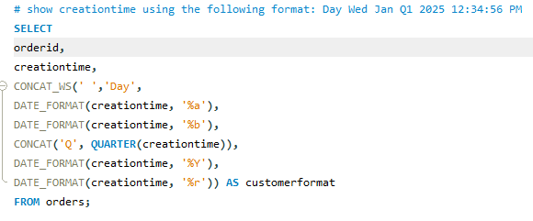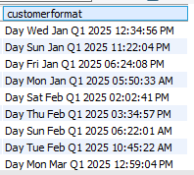

CONVERT
Converts a date or time value to a different data type and formats the value
- CONVERT(data_type, value [,style])
- CONVERT(INT, ‘124’)
- CONVERT(VARCHAR, orderdate, ‘34’)

CAST
Convert a value to a specified data type
- CAST(value AS data_type)
- CAST(‘123’ AS INT)
- CAST(‘2025-08-20’ AS DATE)
No format can be specified

Lecture 17

Content: Date & Time - DATEADD,DATEDIFF, DATESUB, ISDATE | Date: December 15th

DATE_ADD
Adds or subtracts a specific time interval to/from a date.
You can use this function to do some calculations with parts of a date
- DATE_ADD(part, interval, date)
- DATE_ADD(year, 2, orderdate)
- DATE_ADD(month, -4, orderdate)
- DATE_ADD(day, 5, orderdate)
In MySQL
- DATE_ADD(date, INTERVAL value addunit)
- DATE_ADD(creationtime, INTERVAL 10 YEAR) AS date_added

TIMESTAMPDIFF
Find the difference between the two dates
- TIMESTAMPDIFF(part, date1, date2)
- TIMESTAMPDIFF(year, orderdate, shipdate)
ISDATE
Check if a value is a date
Returns 1 if the string value is a valid date
ISDATE(value)

MySQL Equivalency
STR_TO_DATE(my_string, ‘%d/%m/%Y’) IS NOT NULL
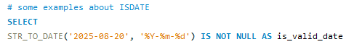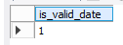

Summary about DATETIME Functions
On the left side there are the SQL SERVER functions and on the right their equivalency in MySQL
Part Extraction
- DAY | DAY
- MONTH |MONTH
- YEAR | YEAR
- DATEPART | EXTRACT
- DATENAME | DAYNAME / MONTHNAME
- DATETRUNC
- EOMONTH | LAST_DAY
Format and Casting
- FORMAT | DATE_FORMAT
- CONVERT | CONVERT
- CAST | CAST
Calculations
- DATEADD | DATE_ADD
- DATEDIFF | TIMESTAMPDIFF
Validation
- ISDATE | STR_TO_DATE('2025-08-20', '%Y-%m-%d') IS NOT NULL

General Syntax of All Functions
Part Extraction
DAY(date)
Returns only the day from a date

MONTH(date)
Return only the month from a date

YEAR(date)
Return only the year from a date

EXTRACT(DAY FROM date)|EXTRACT(MONTH FROM date)|EXTRACT(YEAR FROM date)
Similar to the individual functions, you can specify what do you want retrieve of the date
DAYNAME(date)|MONTHNAME(date)
Return the full name of the week (Sunday-Saturday) or full month name (January-December)

LAST_DAY(date)
Return the date with the last day possible for that month
Format and Casting
DATE_FORMAT(date, ‘format-expression’)
Used to format a date into a different string representation (%y, %Y, %D, there is a table about all placeholders above on the document)

CONVERT(value, DATE) | CONVERT(value, type)
Convert a value to a DATE datatype, but can be use for converting a value into others datatypes

CAST(value AS DATE) | CAST(value AS datatype)
Convert a value of any type into the specified datatype (it’s similar to convert, only the syntax has some difference)

Calculations
DATE_ADD(date, INTERVAL value addunit)
Adds a time/date interval to a date and then returns the date. (date: what date will be added, value: how many of addunit will be added, addunit: month, day or year for calculation)

TIMESTAMPDIFF(unit, oldestdate, newestdate)
Calculates the difference between two dates and return some part of it, like month, day or year.

Validation
STR_TO_DATE('2025-08-20', '%Y-%m-%d') IS NOT NULL
Function to verify if a date is valid or not on the default SQL date formats. Similar to SQL Server ISDATE().
Lecture 18

Content: COALESCE, ISNULL, NULLIF IS (NOT) NULL | Date: December 22nd

What is NULL
NULL means nothing, unknown
NULL is not equal to anything!
- NULL is not zero
- NULL is not empty string
- NULL is not blank space
NULL functions
- Replace Values: IFNULL, COALESCE, NULLIF
- Check for NULLs: IS NULL, IS NOT NULL
IFNULL
Replaces ‘NULL’ with a specified value
- IFNULL(value, replacement_value)
- IFNULL(shipping_address, ‘unknown’)
- IFNULL(shipping_address, billing_address),

IFNULL(shipping_address, billing_address)
Ordered | Shipment_address | Billing_address | ISNULL
1 | A | B | A
2 | NULL | C | C
3 | NULL | NULL | NULL

COALESCE()
Returns the first non-null value from a list
- COALESCE(value1, value2, value3, ….)
- COALESCE(shipping_address, ‘unknown’)
- COALESCE(shipping_address, billing_address)
- COALESCE(shipping_address, billing_address, ‘unknown’)

COALESCE(shipping_address, billing_address)
Ordered | Shipment_address | Billing_address | COALESCE
1 | A | B | A
2 | NULL | C | C
3 | NULL | NULL | NULL

IFNULL vs COALESCE
IFNULL | COALESCE
Limited to two values | Unlimited
Fast | Slow
SQL Server -> ISNULL  ORACLE -> NVL  MySQL -> IFNULL | Available in all databases

Use case – Handling NULLS
- Handle the NULL before doing data aggregations
- Handle the NULL before doing mathematical operations
- Handle the NULL before JOINING tables
- Handle the NULL before sorting data

NULLIF()
Compares two expressions and returns:
- NULL, if they are equal
- First value, if they are not equal
Examples
- NULLIF(value1, value2)
- NULLIF(shipping_address, ‘unknown’)
- NULLIF(shipping_address, billing_address)

Use case - NULLIF
Preventing the error of dividing by zero

IS NULL & IS NOT NULL
IS NULL -> Returns TRUE if the value IS NULL, otherwise it returns FALSE
IS NOT NULL -> Returns TRUE if the value IS NOT NULL, otherwise it returns FALSE
- Value IS NULL || Value IS NOT NULL
- Shipping_address IS NULL
- Shipping_address IS NOT NULL
Use case – IS NULL
- Searching for missing information
- Finding the unmatched rows between two tables

Lecture 19

Content: NULL vs Empty String vs Blank Space | Date: December 22nd

NULL
Means nothing, unknown!

Empty String ‘’
String value has no characters

Blank Space ‘ ‘
String value has one or more space characters
 | NULL | Empty String | Blank Space
Representation | NULL | ‘’ | ‘ ‘
Meaning | Unknown | Known, empty value | Known, space value
Data Type | Special Marker | String(0) | String(1 or more)
Storage | Very Minimal | Occupies memory | Occupies memory (each space)
Performance | Best | Fast | Slow
Comparison | IS NULL | =’’ | =’ ‘

Data Policies
Set of rules that defines how data should be handled

#1 Data policy
Only use NULLs and empty strings, but avoid blank spaces.
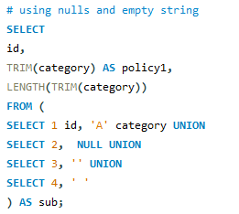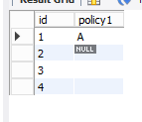

#2 Data policy
Only use NULLs and avoid using empty strings and blank spaces
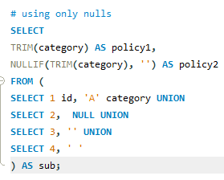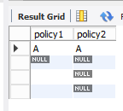
#3 Data policy
Use the default value ‘unknown’ and avoid using nulls, empty strings, and blank spaces
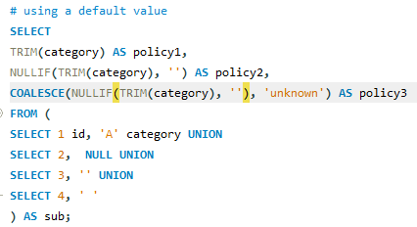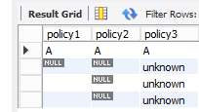

#2 Data policy – Use case before inserting into a database
Replacing empty strings and blanks with NULL during data preparation before inserting into a database to optimize storage and performance.

#3 Data policy – Use case before showing it in a report
Replacing empty strings, blanks, NULL with default value during data preparation before using it in reporting to improve readibility

Summary (NULLs vs Empty String vs Blank Spaces)
- NULLs special markers means missing value
- Using NULLs can optimize storage and performance
NULL Functions
- COALESCE | IFNULL (NULL -> 30)
- NULLIF (30 -> NULL)
- IS NULL | IS OT NULL (TRUE || FALSE)
Use cases
- Handle NULLs – Data aggregation
- Handle NULLs – mathematical operations
- Handle NULLs – Joining Tables
- Handle NULLs – Sorting data
- Finding unmatched data – LEFT ANTI JOIN
- Data Policies (NULLs | Default Value)

Lecture 20

Content: SQL CASE WHEN Statement | Date: February 25th

CASE Statement
Evaluates a list of conditions and returns a value when the first condition is met
Syntax
CASE
WHEN condition1 THEN result1
WHEN condition2 THEN result2
WHEN condition3 THEN result3
ELSE result
END

How it works
sales | CASE
60 | High
30 | NULL
15 | NULL
NULL | NULL

CASE
WHEN sales > 50 THEN ‘High’
END

CASE
sales | CASE
60 | High
30 | Medium
15 | NULL
NULL | NULL
WHEN sales > 50 THEN ‘High’
WHEN sales > 20 THEN ‘Medium’
END

CASE
sales | CASE
60 | High
30 | Medium
15 | Low
NULL | Low
WHEN sales > 50 THEN ‘High’
WHEN sales > 20 THEN ‘Medium’
ELSE ‘Low’
END

Rules – Case statement
The data type of the results must be matching

Case statement can be used anywhere in the query

#1 Use Case – Categorizing Data

Main purpose is Data Transformation
Derive new information
- Create new Column based on existing data

Categorizing Data
Group the data into different categories based on certain conditions

#2 Use Case - Mapping Values
Transform the values from one form to another

For example, in some databases the order status can be stored as 0 or 1, and when generating reports, you might want to transform 0 and 1 into ‘active’ and ‘inactive’

Status
0
1
Status
Inactive
active

Quick Form
When you have to compare one single variable/column to many values, you can use the short form of CASE instead of typing the same thing thousand times:

CASE
WHEN country = ‘Germany’ THEN ‘DE’
WHEN country = ‘India’ THEN ‘IN’
WHEN country = ‘United States THEN ‘US’
WHEN country = ‘France’ THEN ‘FR’
WHEN country = ‘Italy’ THEN ‘IT’
ELSE ‘n/a’
END

In short form, you can specify the value you want to compare after CASE statement word, and just specify the value you will evaluate to the default value:

CASE country
WHEN ‘Germany’ THEN ‘DE’
WHEN ‘India’ THEN ‘IN’
WHEN ‘United States THEN ‘US’
WHEN ‘France’ THEN ‘FR’
WHEN ‘Italy’ THEN ‘IT’
ELSE ‘n/a’
END

# 3 Use case – Handling NULLS

Replace NULLs with a specific value
NULLs can lead to inaccurate results, which can lead to wrong decision-making

# 4 Use case – Conditional Aggregation

Apply aggregate functions only on subsets of data that fulfill certain condtions

Lecture 21

Content: Aggregate Functions – COUNT, SUM, AVG, MAX, MIN | Date: March 4th

Review
COUNT(*)
Count the number of rows inside a table

SUM()
Take some values and return the sum of them

AVG()
Sum all values and calculates the average between them

MAX()
Find the highest number value inside a column

MIN()
Find the lowest number value inside a column

Lecture 22

Content: Window Functions Basics – PARTITION BY, ORDER BY | Date: March 4th

What are Window Functions
Perform calculations (for example: aggregation) on a specific subset of data, without losing the level of details of rows.

How GROUP BY works
ID | PRODUCT | SALES
1 | Cap | 10
2 | Cap | 30
3 | Gloves | 5
4 | Gloves | 20
Let’s say you would like to see the total sales for each product:
PRODUCT | TOTAL_SALES
Caps | 40
Gloves | 25

The final number of rows will be depending on the number of products we have stored on the database, and the final result will not show the id and additional information about the products, it will only show the name of each product and the total_sales. Small level of details.

Same task but using Window Function
ID | PRODUCT | SALES
1 | Cap | 10
2 | Cap | 30
3 | Gloves | 5
4 | Gloves | 20
Total sales for each product. If you use window function SQL will execute each row individually from each other. Then, you aren’t going to lose additional information about the products.
ID | PRODUCT | Total_Sales
1 | Cap | 40
2 | Cap | 40
3 | Gloves | 25
4 | Gloves | 25

When you use window function, you are doing row-level calculations. For the previous example: in input data you have four rows, and in the output, you’re going to get four rows as well.
Both methods were able to solve the task. But:
- GROUP BY returns a single row for each group (changes the granularity)
- Window returns a result for each row (the granularity stays the same)

Function Differences between GROUP BY and Window Functions
GROUP BY Functions |  | Window Functions
Aggregate Functions | COUNT(expr) | Aggregate Functions | COUNT(expr)
 | SUM(expr) |  | SUM(expr)
 | AVG(expr) |  | AVG(expr)
 | MIN(expr) |  | MIN(expr)
 | MAX(expr) |  | MAX(expr)
 |  | Rank Functions | ROW_NUMBER()
 |  |  | RANK()
 |  |  | DENSE_RANK()
 |  |  | CUME_DIST()
 |  |  | PERCENT_RANK()
 |  |  | NTILE(n)
 |  | Value (Analytics) Functions | LEAD(expr,offset,default)
 |  |  | LAG(expr,offset,default)
 |  |  | FIRST_VALUE(expr)
 |  |  | FIRST_VALUE(expr)

Window Functions – The syntax
Window Function | OVER Clause
F(x) | PARTITION Clause + ORDER Clause + Frame Clause

Example
AVG(sales) OVER (PARTITION BY Category ORDER BY Orderdate ROWS UNBOUNDED PRECEDING)
AVG(sales)
a simple window function

Sales value inside AVG()
it’s a Function Expression / Arguments you pass to a function
Function Expression Cases:
Empty | RANK() OVER (ORDER BY OrderDate)
Column | AVG(Sales) OVER (ORDER BY OrderDate)
Number | NTILE(2) OVER (ORDER BY OrderDate)
Multiple Arguments | LEAD(Sales, 2, 10) OVER (ORDER BY OrderDate)
Conditional Logic | SUM(CASE WHEN Sales > 100 THEN 1 ELSE 0 END) OVER (ORDER BY OrderDate)

OVER ()
Tells SQL that the function used is a window function, it defines a window or subset of data

PARTITION BY
Divides the result into partitions (windows). It tells to SQL how to divide your data

ORDER BY
Sort the data within a window (Ascending | Descending)
Window Frame
Defines a subset of rows within each window that is relevant for the calculation

Example
AVG(sales) OVER (PARTITION BY Category ORDER BY Orderdate ROWS BETWEEN CURRENT ROW AND UNBOUNDED PRECEDING)
ROWS | BETWEEN | CURRENT ROW | AND | UNBOUNDED PRECEDING
Frame Types |  | Frame Boundary (Lower value) |  | Frame Boundary (Higher Value)
ROWS |  | CURRENT ROW |  | CURRENT ROW
RANGE |  | N PRECEDING |  | N FOLLOWING
 |  | UNBOUNDED PRECEDING |  | UNBOUNDED FOLLOWING

Rules
- Frame Clause can only be used together with order by clause
- Lower value must be before the higher value
Compact Frame
For only PRECEDING, the CURRENT ROW can be skipped
- NORMAL FORM: ROWS BETWEEN CURRENT ROW AND 2 FOLLOWING
- SHORT FORM: ROWS 2 FOLLOWING

Window Function – Rules
# 1 Rule
Window Functions can be used ONLY in SELECT and ORDER BY Clause

# 2 Rule
Nesting Window Functions is not allowed

# 3 Rule
SQL execute Window Functions after WHERE Clause

# 4 Rule
Window Function can be used together with GROUP BY in the same query, ONLY if the same columns are used
Lecture 23

Content: Aggregate Window Functions – COUNT, AVG, SUM, MAX, MIN | Date: March 26th

GROUP BY Functions |  | Expression | Partition Clause | Order Clause | Frame Clause
Aggregate Functions | COUNT(expr) | All Data Type | Optional | Optional | Optional
 | SUM(expr) | Numeric Values
 | AVG(expr) | Numeric Values
 | MIN(expr) | Numeric Values
 | MAX(expr) | Numeric Values

COUNT
Return the number of rows within a window, counts the number of non-NULL values in the column
COUNT(1) == COUNT(*)
Counts the number of values in a column, regardless of their data types

COUNT(Product) OVER(PARTITION BY Product)
Product | Sales | COUNT
Caps | 20 | 3
Caps | 10 | 3
Caps | 5 | 3
Gloves | 30 | 3
Gloves | 70 | 3
Gloves | NULL | 3

Two partitions
Data Quality Issue
Duplicates leads to inaccuracies in analysis, COUNT() can be used to identify duplicates
Example 01
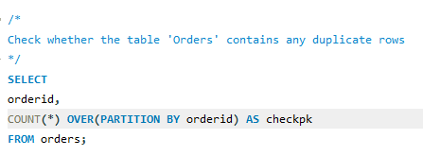
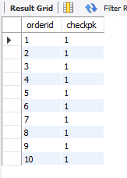
As you can see, all lines from ‘checkpk’ column have the value one, therefore we do not have any duplicates

Example 02
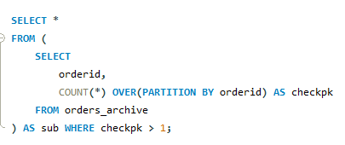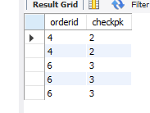
In this second example, ‘checkpk’ column returns more than one, as a result we found duplicates in it

COUNT USECASES
- #1 Overall Analysis
- #2 Category Analysis
- #3 Quality Checks: Identify NULLs
- #4 Quality Checks: Identify Duplicates

SUM
Return the sum of values within a window
SUM(Sales) OVER(PARTITION BY Product)
Product | Sales | SUM
Caps | 20 | 35
Caps | 10 | 35
Caps | 5 | 35
Gloves | 30 | 100
Gloves | 70 | 100
Gloves | NULL | 100

AVG
Returns the average of values within a window
Task: Find the average sales for each product
AVG(COALESCE(Sales,0)) OVER(PARTITION BY Product)
Product | Sales | AVG
Caps | 20 | 11
Caps | 10 | 11
Caps | 5 | 11
Gloves | 30 | 33
Gloves | 70 | 33
Gloves | 0 | 33

MIN / MAX
- MIN: Returns the lowest value within a window
- MAX: Returns the highest value within a window

MIN(sales) OVER(PARTITION BY Product)
Product | Sales | MIN
Caps | 20 | 5
Caps | 10 | 5
Caps | 5 | 5
Gloves | 30 | 30
Gloves | 70 | 30
Gloves | NULL | 30

MAX(sales) OVER(PARTITION BY Product)
Product | Sales | MIN
Caps | 20 | 20
Caps | 10 | 20
Caps | 5 | 20
Gloves | 30 | 70
Gloves | 70 | 70
Gloves | NULL | 70

RUNNING AND ROLLING TOTAL
They aggregate sequence of members, and the aggregation is updated each time a new member is added (analysis over time).
RUNNING TOTAL
Aggregate all values from the beginning up to the current point without dropping off older data.
ROLLING TOTAL
Aggregate all values within a fixed time window (e.g. 30 days). As new data is added, the oldest data point will be dropped.

Example
RUNNING TOTAL |  |  | ROLLING TOTAL
Task: To find the running total sales for each month |  |  | Task: to find three month rolling total of the sales for each month
SUM(sales) OVER(ORDER BY Month) |  |  | SUM(sales) OVER(ORDER BY Month ROWS BETWEEN 2 PRECEDING AND CURRENT ROW)
Default: ROWS BETWEEN UNBOUNDED PRECEDING AND CURRENT ROW
Month | Sales | SUM | Month | Sales | SUM
January | 20 | 20 | January | 20 | 20
February | 10 | 30 | February | 10 | 30
March | 30 | 60 | March | 30 | 60
April | 5 | 65 | April | 5 | 45
June | 70 | 135 | June | 70 | 105
July | 40 | 175 | July | 40 | 115

Overview of Aggregation Functions
Overall Total |  |  | Total Per Groups |  |  | Running Total |  |  | Rolling Total
SUM(sales) OVER() |  |  | SUM(sales) OVER (PARTITION BY product) |  |  | SUM(sales) OVER (ORDER BY MONTH) |  |  | SUM(sales) OVER (ORDER BY MONTH ROWS 2 PRECEDING)
Overview of entire data |  |  | Compare Categories |  |  | Progress Over Time |  |  | Progress over time in specific fixed window
Month | Sales | SUM | Month | Sales | SUM | Month | Sales | SUM | Month | Sales | SUM
Caps | 20 | 175 | Caps | 20 | 60 | Caps | 20 | 20 | Caps | 20 | 20
Caps | 10 | 175 | Caps | 10 | 60 | Caps | 10 | 30 | Caps | 10 | 30
Caps | 30 | 175 | Caps | 30 | 60 | Caps | 30 | 60 | Caps | 30 | 60
Gloves | 5 | 175 | Gloves | 5 | 105 | Gloves | 5 | 65 | Gloves | 5 | 45
Gloves | 70 | 175 | Gloves | 70 | 105 | Gloves | 70 | 135 | Gloves | 70 | 105
Gloves | 40 | 175 | Gloves | 40 | 105 | Gloves | 40 | 175 | Gloves | 40 | 115

Lecture 24

Content: Ranking Window Functions – ROW_NUMBER, RANK, DENSE_RANK, NTILE | Date: April 3rd

What are RANKING WINDOW FUNCTIONS
 |  | Top/Button N Analysis | Distribution Analysis
 |  | Integer-based ranking | Percentage-based ranking
products | sales | Discrete values | Continuous values
E | 70 | 1 | 0
B | 30 | 2 | 0.25
A | 20 | 3 | 0.50
C | 10 | 4 | 0.75
D | 5 | 5 | 1
 |  | Functions  ROW_NUMBER()  RANK()  DENSE_RANK()  NTILE() | Functions  CUME_DIST()  PERCENT_RANK()

Syntax
RANK() OVER(PARTITION BY productid ORDER BY sales)
Expression must be empty, PARTITION BY is optional and ORDER BY is required

RANK FUNCTIONS
 |  | EXPRESSION | PARTITION CLAUSE | ORDER CLAUSE | FRAME CLAUSE
RANK FUNCTIONS | ROW_NUMBER() | EMPTY | OPTIONAL | REQUIRED | NOT ALLOWED
 | RANK()
 | DENSE_RANK()
 | CUME_DIST()
 | PERCENT_RANK()
 | NTILE(n) | NUMBER

RANK  FUNCTIONS | ROW_NUMBER() | Assign a unique number to each in a window | ROW_NUMBER() OVER (ORDER BY sales)
 | RANK() | Assign a rank to each row in a window, with gaps | RANK() OVER (ORDER BY sales)
 | DENSE_RANK() | Assign a rank to each row in a window, without gaps | DENSE_RANK() OVER (ORDER BY sales)
 | CUME_DIST() | Calculates the cumulative distribution of a value within a set of values | CUME_DIST() OVER (ORDER BY sales)
 | PERCENT_RANK() | Returns the percentile ranking number of a row | PERCENT_RANK() OVER (ORDER BY sales)
 | NTILE(n) | Divides the rows into a specified number of approximately equal groups | NTILE(2) OVER (ORDER BY sales)
ROW_NUMBER
Assign a unique number to each row, it doesn’t handle ties.
ROW_NUMBER() OVER (ORDER BY sales DESC)
sales | RANK
100 | 1
80 | 2
80 | 3
50 | 4
20 | 5

We have the same value twice, but with different ranks, that means ROW_NUMBER doesn’t handle the ties.
RANK
Assign a rank to each row, it handles ties and leaves gaps in ranking
RANK() OVER (ORDER BY sales DESC)
sales | RANK
100 | 1
80 | 2
80 | 2
50 | 4
20 | 5

There’s no a unique rank here, since some sales values are sharing the same rank, but RANK function leave gaps in rank numbers, in this example it skipped the value 3
DENSE_RANK
Assign a rank to each row, it handles ties and doesn’t leave gaps in ranking
DENSE_RANK() OVER (ORDER BY sales DESC)
sales | RANK
100 | 1
80 | 2
80 | 2
50 | 3
20 | 4

We have shared ranks, but this time there’s no skipped rank numbers

INTEGER-BASE RANKING – COMPARISON
ROW_NUMBER() |  | RANK() |  | DENSE_RANK()
ROW_NUMBER() OVER (ORDER BY sales DESC) |  | RANK() OVER (ORDER BY sales DESC) |  | DENSE_RANK() OVER (ORDER BY sales DESC)
sales | RANK | sales | RANK | sales | RANK
100 | 1 | 100 | 1 | 100 | 1
80 | 2 | 80 | 2 | 80 | 2
80 | 3 | 80 | 2 | 80 | 2
50 | 4 | 50 | 4 | 50 | 3
20 | 5 | 20 | 5 | 20 | 4
Unique RANK |  | Shared RANK |  | Shared RANK
Does not handle ties |  | Handles Ties |  | Handles Ties
No gaps in RANKS |  | Gaps in RANKS |  | No gaps in RANKS

PAGINATING
The process of breaking down a large data into smaller, more manageable chunks.
ROW_NUMBER | USE CASES
- Top-N Analysis
- Bottom-N Analysis
- Assign unique IDs
- Quality Checks: Identify Duplicates

NTILE
Divides the rows into a specified number of approximately equal groups (Buckets)
Bucket size = $\frac{Number of rows}{number of buckets}$
NTILE(2) OVER (ORDER BY sales DESC)
sales | NTILE
100 | 1
80 | 1
80 | 1
50 | 2
30 | 2

NTILE | USE CASES
- Data Analyst: Data Segmentation
- Data Engineer: Equalizing load processing
DATA SEGMENTATION
Divides a dataset into distinct subsets based on certain criteria
EQUALIZING DATA
Breaks the entire data into small parts in order to be handled easily

PERCENTAGE-BASED RANKING
- CUME_DIST = position number / number of rows
- PERCENTAGE_RANK = position number – 1 / number of rows – 1
CUME_DIST
Cumulative distribution calculates the distribution of data points within a window
CUME_DIST = $\frac{position number}{number of rows}$
CUME_DIST() OVER (ORDER BY sales DESC)
sales | DIST
100 | 0.20
80 | 0.60
80 | 0.60
50 | 0.80
30 | 1.00

PERCENT_RANK
Calculates the relative position of each row
PERCENT_RANK = $\frac{position number-1}{number of rows-1}$
PERCENT_RANK() OVER (ORDER BY sales DESC)
sales | per
100 | 0
80 | 0.25
80 | 0.25
50 | 0.75
30 | 1.00

TIE RULE
- CUME_DIST: The position of the last occurrence of the same value
- PERCENT_RANK: The position of the first occurrence of the same value

Lecture 25

Content: Value Window Functions – LEAD, LAG, FIRST_VALUE, LAST_VALUE | Date: April 3rd

WHAT ARE VALUE WINDOW FUNCTIONS
Are functions that you can use to access values from other rows
SYNTAX
 |  | EXPRESSION | PARTITION CLAUSE | ORDER CLAUSE | FRAME CLAUSE
VALUE ANALYTICS FUNCTIONS | LEAD(expr, offset, default) | ALL DATA TYPE | OPTIONAL | REQUIRED | NOT ALLOWED
 | LAG(expr, offset, default)
 | FIRST_VALUE(expr) |  |  |  | OPTIONAL
 | LAST_VALUE(expr) |  |  |  | SHOULD BE USED

LEAD
Access a value from the next row within a window
LAG
Access a value from the previous row within a window

Example
LEAD(sales, 2, 10) OVER(PARTITION BY productid ORDER BY orderdate)
- Sales: expression is required (any data type)
- 2: offset (optional) number of rows forward or backward from current row, default = 1
- 10: default value (optional) returns default value if next/previous row is not available, default = NULL

LEAD/LAG(sales) OVER(ORDER BY orderdate)
month | sales | LEAD
Jan | 20 | 10
Feb | 10 | 30
Mar | 30 | 5
Apr | 5 | NULL
month | sales | LAG
Jan | 20 | NULL
Feb | 10 | 20
Mar | 30 | 10
Apr | 5 | 30

LEAD(sales,2,0) OVER (ORDER BY month) |  |  | LAG(sales,2,0) OVER (ORDER BY month)
Find the sales for the two months ahead |  |  | Find the sales for the two months ago
month | sales | LEAD | month | sales | LAG
Jan | 20 | 30 | Jan | 20 | 0
Feb | 10 | 5 | Feb | 10 | 0
Mar | 30 | 0 | Mar | 30 | 20
Apr | 5 | 0 | Apr | 5 | 10

TIME SERIES ANALYSIS
The process of analyzing the data to understand patterns, trends, and behaviors over time
- Year-over-Year (YoY): Analyze the overall growth or decline of the business performance over time
- Month-over-Month (MoM): Analyze short-term trends and discover patterns in seasonality

CUSTOMER RETENTION ANALYSIS
Measure customer’s behavior and loyalty to help businesses build strong relationships with customers

FIRST_VALUE
Access a value from the first row within a window
LAST_VALUE
Access a value from the last row within a window
FIRST_VALUE(sales) OVER (ORDER BY month) |  |  | LAST_VALUE(sales) OVER (ORDER BY month)
DEFAULT RANGE: RANGE BETWEEN UNBOUNDED PRECEDING AND CURRENT ROW
month | sales | FIRST | month | sales | LAST
Jan | 20 | 20 | Jan | 20 | 20
Feb | 10 | 20 | Feb | 10 | 10
Mar | 30 | 20 | Mar | 30 | 30
Apr | 5 | 20 | Apr | 5 | 5

FIRST_VALUE will work properly in the default RANGE, but for getting the expected result in LAST_VALUE, you need to specify a different RANGE
LAST_VALUE(sales) OVER (ORDER BY month ROWS BETWEEN CURRENT ROW AND UNBOUNDED FOLLOWING)
month | sales | LAST
Jan | 20 | 5
Feb | 10 | 5
Mar | 30 | 5
Apr | 5 | 5

WINDOW VALUE (ANALYTICAL) FUNCTIONS SUMMARY
Allow access specific value from another row
Types
- Previous value: LAG
- Next value: LEAD
- First value: FIRST_VALUE
- Last value: LAST_VALUE
Rules
- Expression: Any data type
- ORDER BY: required
- Frame: optional
Use Cases
- Time series Analysis: MoM and YoY
- Time gaps analysis: Customer retention
- Comparison analysis: Extreme Highest/Lowest

Lecture 26

Content: Five SQL Techniques You Need in Every Project | Date: April 4th

Data Warehouse
A special database that collects and integrates data from different sources to enable analytics and support decision-making
Simplified Database Architecture
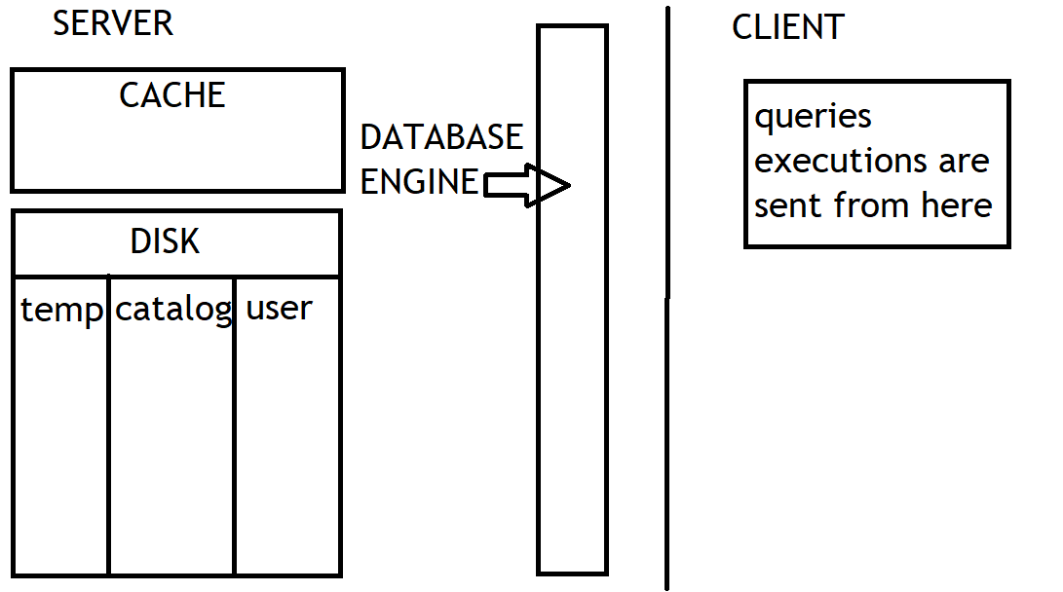
DATABASE ENGINE
It is the brain of the database, executing multiple operations such as storing, retrieving, and managing data within the database
DISK STORAGE
- Long-term memory, where data is stored permanently
- +capacity: can hold a large amount of data
- -speed: slow to read and to write
CACHE
- Fast short-term memory, where data is stored temporarily
- +speed: extremely fast to read and to write
- -capacity: can hold smaller amount of data
USER DATA STORAGE
It’s the main content of the database. This is where the actual data that users care about is stored
SYSTEM CATALOG
Database’s internal storage for its own information. A blueprint that keeps track of everything about the database itself, not the user data. It holds the Metadata information about the database
METADATA
Data about Data
Example of metadata
Customers Table (actual data)
customerid | firstname | lastname | country | score
1 | Jossef | Goldberg | Germany | 350
2 | Kevin | Brown | USA | 900
3 | Mary |  | USA | 750
4 | Mark | Schwarz | Germany | 500

Metadata of Customers Table (data about data)
table name | column name | data type | length | is nullable
Customers | customerid | int |  | no
Customers | firstname | varchar | 50 | yes
Customers | lastname | varchar | 50 | yes
Customers | country | varchar | 50 | yes
Customers | score | int |  | yes

INFORMATION SCHEMA
A system-defined schema with built-in views that provide info about the database, like table and columns
TEMP DATA STORAGE
Temporary space used by the database for short-term tasks, like processing queries or sorting data, once these tasks are done, the storage is cleared
Importance of the five SQL techniques for optimizing queries
Challenges without those techniques
- Redundancy
- Performance issues
- Complexity
- Hard to maintain
- DB Stress
- Security
Solutions
- Subquery
- CTE (Common Table Expression)
- Views
- Temp Tables
- CTAS (Create Table As Select)

Lecture 27

Content: Subqueries – Complete Guide | Date: April 4th

What is Subquery
A query inside another query, they can be used in order to simplify queries
Why Subqueries
In complex tasks, you might have to do several in the same query, and it can get very difficult, because the query can become unreadable and very long to debug.
Example:
Steps for a task | Query (non-subquery) | Subquery
Step 1: Join Tables | Will be a really big query, really hard to debug and understand | Query 1
Step 2: Filtering |  | Query 2
Step 3: Transformations |  | Query 3
Step 4: Aggregations |  | Main Query

Categories
Result Types
Scalar  (One single value) | Row  (Multiple rows and single column) | Table  (Multiple rows and multiple columns)

Dependency
Non-Correlated | Correlated

Location | Clause
SELECT | FROM | JOIN | WHERE
 |  |  | Comparison Operators | Logical Operators
 |  |  | < > = != >= <= | IN, ANY, ALL EXISTS

Subquery in FROM Clause
SELECT *
FROM (SELECT column FROM table1 WHERE condition)
Subquery in SELECT Clause
SELECT Column1,
(SELECT Column FROM table1 WHERE condition) AS alias
FROM table1
Rules – SELECT subquery
Only scalar subqueries are allowed to be used

Subquery in JOIN Clause
Used to prepare the data (filtering or aggregation) before joining it with other tables
Subquery in WHERE Clause ANY operator
SELECT column1, column2
FROM table1
WHERE column < ANY(SELECT column FROM table1 WHERE condition)

Non-Correlated Subquery
A subquery that can run independently from the Main Query
Correlated Subquery
A subquery that relays on values from the Main Query

 | Non-Correlated Subquery | Correlated Subquery
Definition | Subquery is independent of the main query | Subquery is dependent of the main query
Execution | Executed once and its result is used by the main query  Can be executed on its Own | Executed for each row processed by the main query  Can’t be executed on its Own
Easy to use | Easier to read | Harder to read and more complex
Performance | Executed only once leads to better performance | Executed multiple times leads to bad performance
Usage | Static Comparisons, Filtering with Constants | Row-by-Row comparisons, Dynamic filtering

EXISTS Clause
Check if a subquery returns any rows

SELECT column1, column2
FROM table2
WHERE EXISTS (SELECT 1 FROM table1 WHERE table1.ID = table2.ID)

For each row in Main Query, it runs the subquery
- No result? Rows of main query is excluded
- Returns value? Row of main query is included

Lecture 28

Content: CTE (Common Table Expression) | Date: April 16th

What is CTE
Temporary, named result set (virtual table), that can be used multiple times within your query to simplify and organize complex query
CTE types
- None-Recursive CTE (Standalone CTE, Nested CTE)
- Recursive CTE
Standalone CTE
Defined and used independently. Runs independently as it’s self-contained and doesn’t rely on other CTEs or queries
CTE syntax
WITH CTE-Name AS
(
SELECT
FROM
WHERE
)

SELECT
FROM CTE-Name
WHERE

Multiple Standalone CTEs
WITH CTE-Name1 AS
(
SELECT
FROM
WHERE
)
, WITH CTE-Name2 AS
(
SELECT
FROM
WHERE
)

Nested CTE - Syntax
CTE inside another CTE, a nested CTE uses the result of another CTE, so it can’t run independently
WITH CTE-Name1 AS
(
SELECT
FROM
WHERE
)
, WITH CTE-Name2 AS
(
SELECT
FROM CTE-Name1
WHERE
)

CTE Best Practices
- Rething and refactor your CTEs before starting a new one
- Don’t use more than 5 CTEs in one query, otherwise, your code will be hard to understand and maintain

Recursive CTE
Self-referencing query that repeatedly processes data until a specific condition is met
Recursive CTE - Syntax
WITH CTE-Name AS
(
SELECT -> Anchor query
FROM
WHERE

UNION ALL / UNION

SELECT -> Recursive query
FROM CTE-Name
WHERE (break condition)
)

Lecture 26

Content: Five SQL Techniques You Need in Every Project | Date: April 4th

